Assignment 1 – Linux User & Access Control : Scenario-Based DevSecOps Practical Assessment
Emmanuel Awonate Abaafe

Scenario 1
Part A
- Create a new user called audit_test

2. Ensure the user is created without setting a password

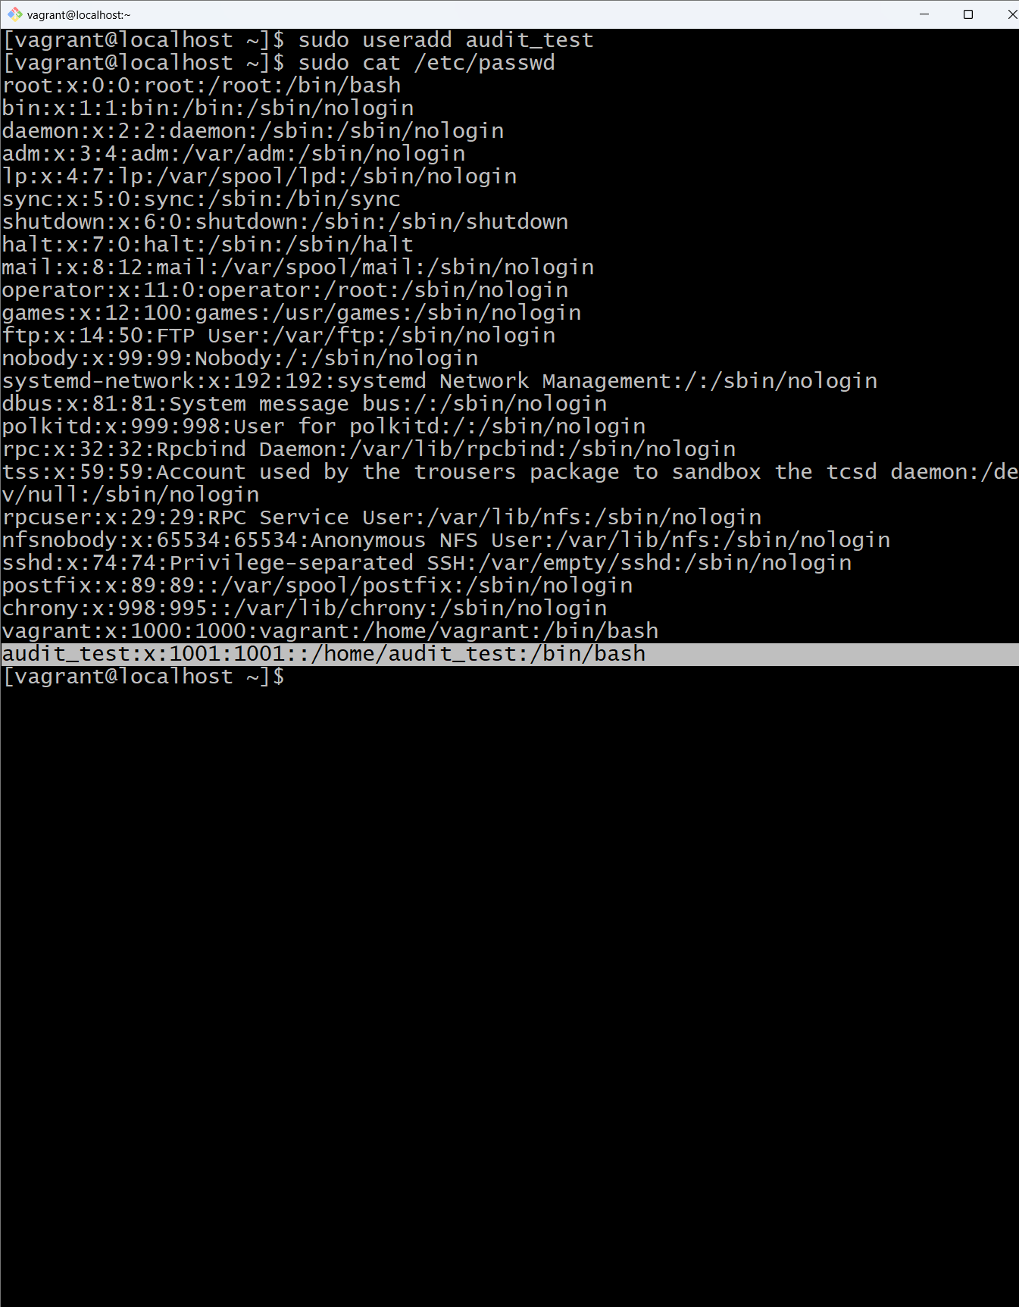
Part B
- Inspect the system location that stores password state
Command : sudo cat/etc/shadow
Evidence

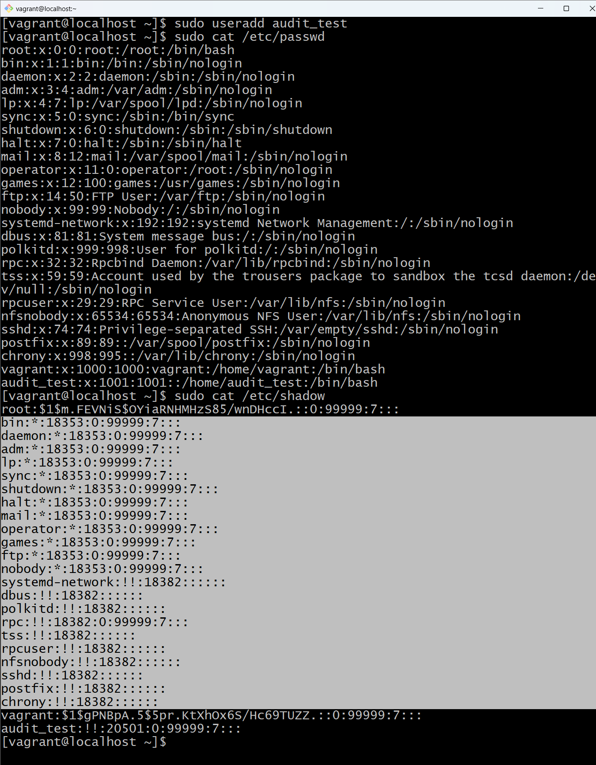
Explanation
The users with * and !! symbols don not have passwords or inactive.
Part C
- Set a password for audit_test
Command: sudo passwd audit_test
Evidence



Clear before-and-after comparison
Before setting a password
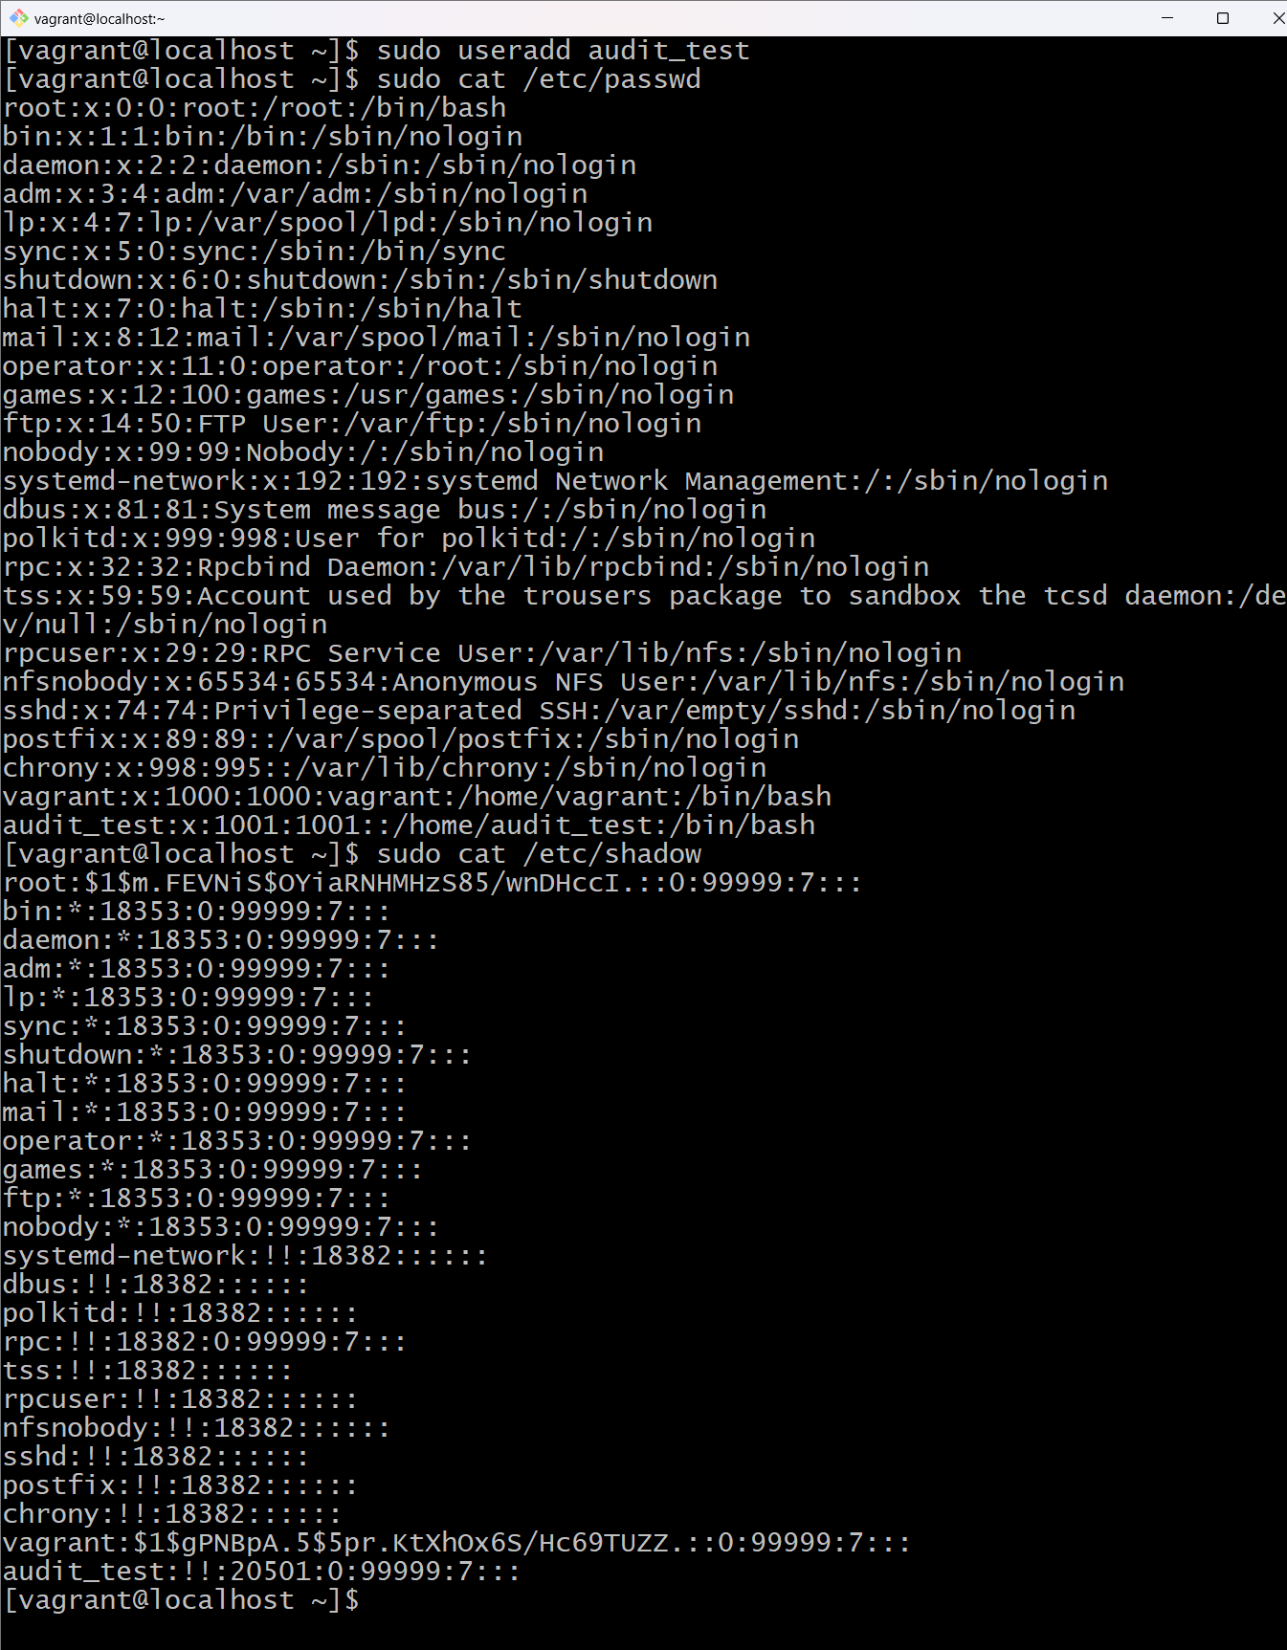
After setting a password
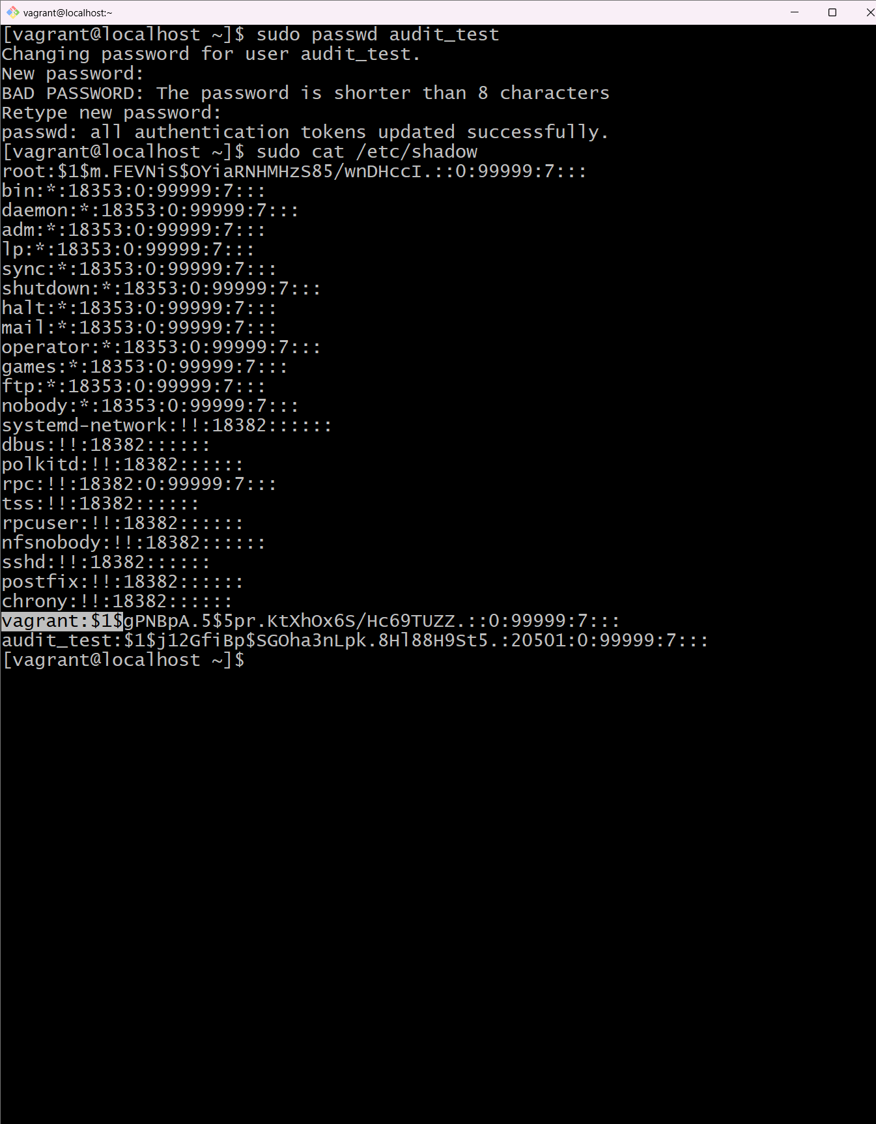

Scenario 2
- Create all onboarded users using a mix of user management commands.
Command: sudo useradd lateef
Command2: sudo adduser Arthur
Evidence


- Assign users to departments as follows:
Command: sudo usermod -aG dev_team lateef
Evidence

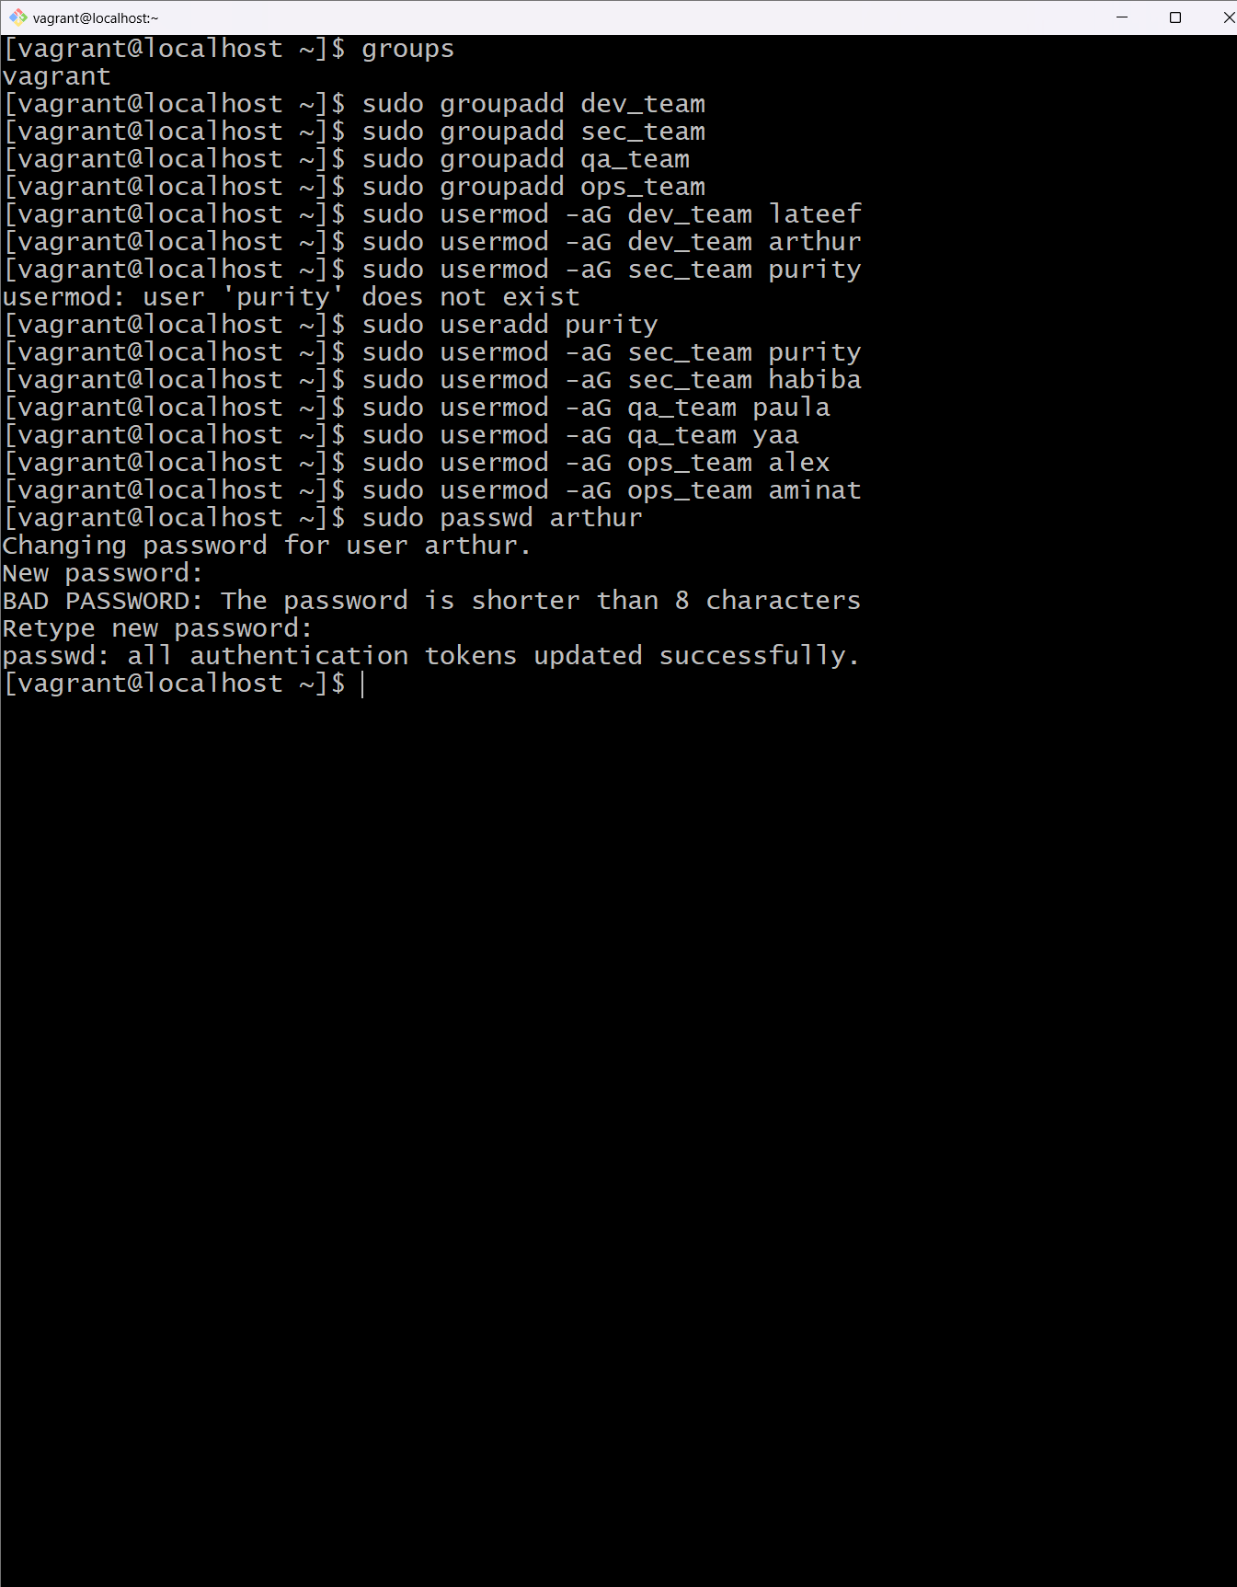

- Ensure one user is created without a password, then later set the password and confirm the change
Command: sudo passwd Arthur
Evidence
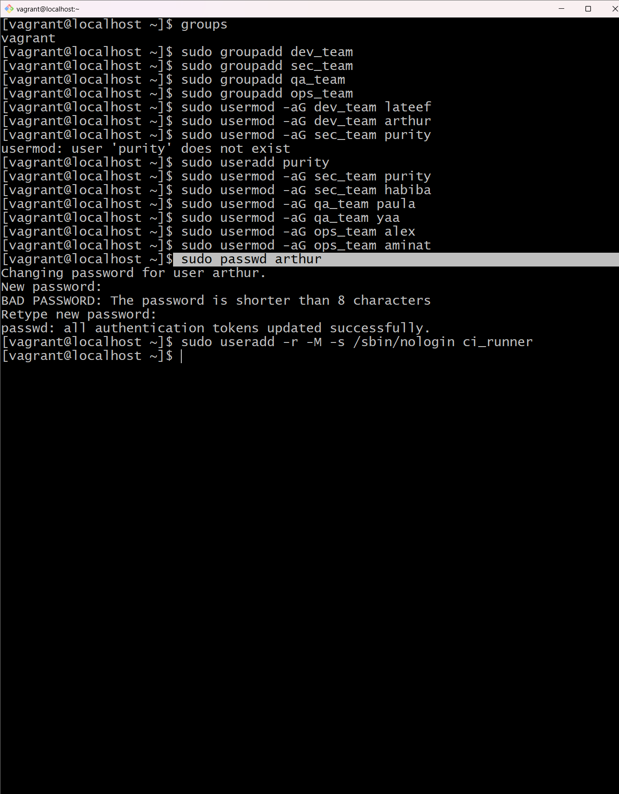
- Configure the ci_runner account with a non-login shell.
Command: sudo adduser -s /sbin/nologin -M ci_runner
Evidence

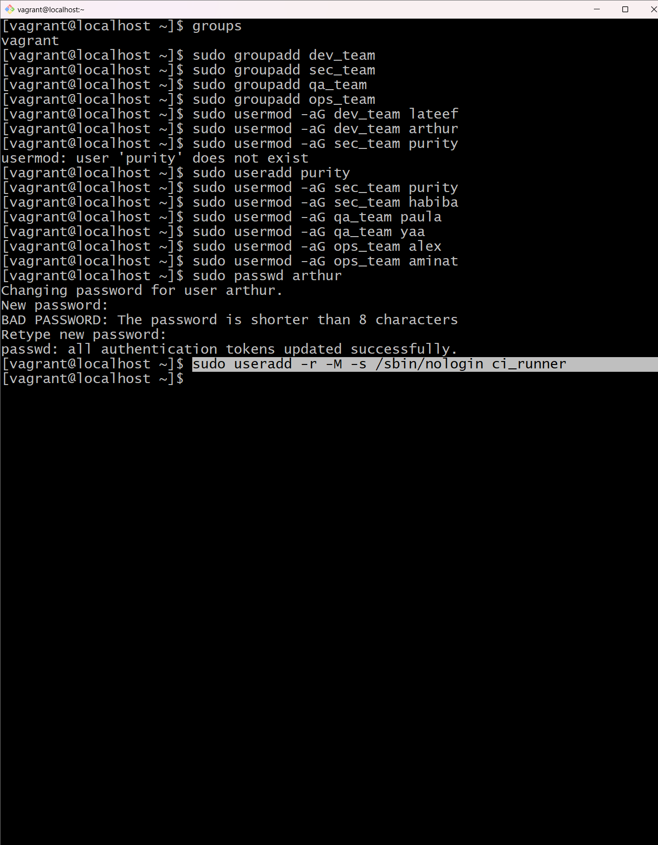

- Grant sudo access to one user from ops_team only; all other users must remain within their department privileges.
Command: sudo usermod -aG wheel alex
Command2: sudo usermod -aG sudo alex
Evidence
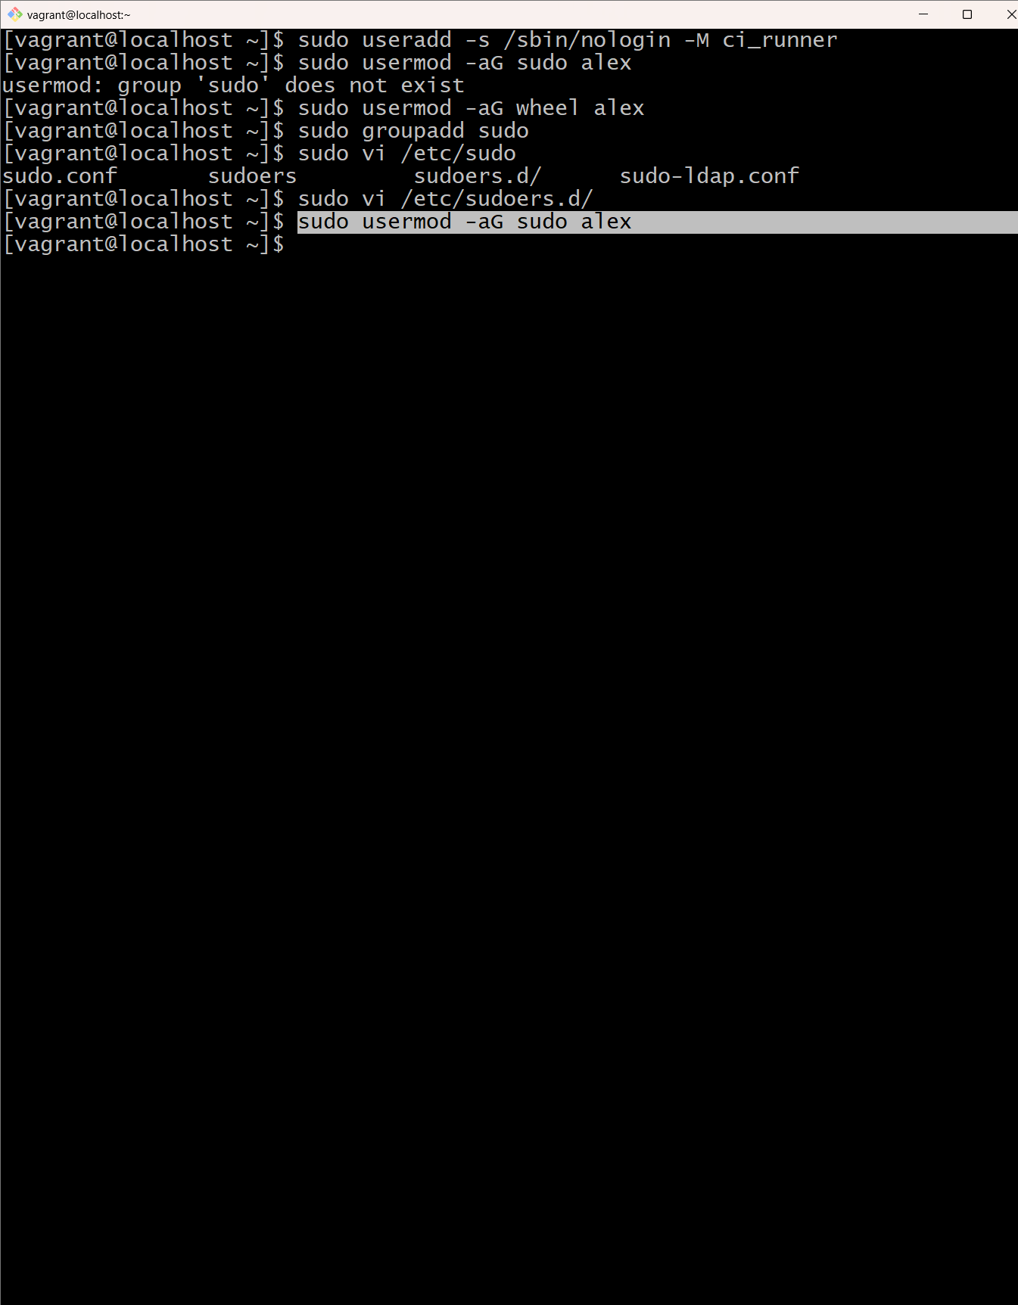

- Remove one user account while preserving the home directory for audit and security reasons.
Command: sudo userdel yaa

Explain, based on observation
- How Linux records and tracks group membership
Answer: When a user is created it is assigned an ID. But because of security concerns users are mostly assigned groups with a certain level of privilege on requirement. So, these groups are stored in a group file under the /etc directory.
We use the sudo cat /etc/group to list all groups within the system

- How department-based grouping enforces access control
Answer: Every group is create with a certain level of access assign to it. Eg. The sudoers group known as sudo has root access and can read, write and execute every file in the linux system. But when a group is even the read privileges, all users assigned to only that group can only read files.
- Why service accounts must use non-login shells?
Answer:This is because those accounts are created to run only services and do not require any interaction with the user. Eg. An Nginx service account only provides nginx service and nothing else therefore making it difficult for hackers to attack.
- Why home directories may be retained after user deletion
Answer:This is because when the directories are retained it helps in auditing and also prevent data loss.
- How privilege escalation is controlled in DevSecOps environments
Answer: In linux privilege escalation is controlled by assigning groups to users with specific privileges also in the cloud we use IAM policies

Appendix: Commands used
1 pwd
2 ls
3 apt --list
4 sudo adduser audit_test
5 sudo ls /etc/passwd
6 sudo cat /etc/passwd
7 sudo cat /etc/shadow
8 sudo passwd -S audit_test
9 sudo userdel audit_test
10 sudo useradd audit_test
11 sudo userdel --remove-home audit_test
12 sudo rm -r /home/audit_test
13 sudo useradd audit_test
14 sudo rm -r /home/audit_test
15 sudo userdel audit_test
16 sudo rm -r /home/audit_test
17 ls
18 sudo cat /etc/passwd
19 sudo useradd audit_test
20 sudo rm -rf /hom/audit_test
21 sudo useradd audit_test
22 sudo userdel audit_test
23 sudo rm -rf /hom/audit_test
24 sudo useradd audit_test
25 id audit_test
26 sudo cat /etc/passwd | grep audit_test
27 sudo userdel -r audit_test
28 sudo cat /etc/passwd
29 sudo useradd audit_test
30 sudo cat /etc/passwd
31 sudo cat /etc/shadow
32 sudo passwd -s -a
33 sudo passwd -S -a
34 sudo getent passwd
35 sudo passwd -S
36 sudo passwd -S -a
37 sudo passwd -S -al
38 sudo passwd audit_test
39 sudo cat /etc/shadow
40 sudo passwd -S audit_test
41 cat /etc/passwd
42 ssh audit_test
43 su audit_test
44 sudo useradd lateef,purity,arthur,paula,yaa,alex,habiba,aminat
45 vi newUsers
46 sudo newusers newUsers
47 sudo useradd lateef
48 sudo useradd arthur
49 sudo useradd paula
50 sudo useradd yaa
51 sudo useradd alex
52 sudo useradd habiba
53 sudo useradd aminat
54 cat /etc/group
55 groups
56 sudo groupadd dev_team
57 sudo groupadd sec_team
58 sudo groupadd qa_team
59 sudo groupadd ops_team
60 sudo usermod -aG dev_team lateef
61 sudo usermod -aG dev_team arthur
62 sudo usermod -aG sec_team purity
63 sudo useradd purity
64 sudo usermod -aG sec_team purity
65 sudo usermod -aG sec_team habiba
66 sudo usermod -aG qa_team paula
67 sudo usermod -aG qa_team yaa
68 sudo usermod -aG ops_team alex
69 sudo usermod -aG ops_team aminat
70 sudo passwd arthur
71 sudo useradd -r -M -s /sbin/nologin ci_runner
72 sudo userdel -r ci_runner
73 sudo useradd ci_runner
74 sudo userdel -r ci_runner
75 sudo useradd -s /sbin/nologin -M ci_runner
76 sudo usermod -aG sudo alex
77 sudo usermod -aG wheel alex
78 sudo groupadd sudo
79 sudo vi /etc/sudoers.d/
80 sudo usermod -aG sudo alex
81 sudo userdel yaa
82 groups
83 sudo cat /etc/group

